Task Manager
Project:11-1 page 505
Snip for Task Manager with Normal Start
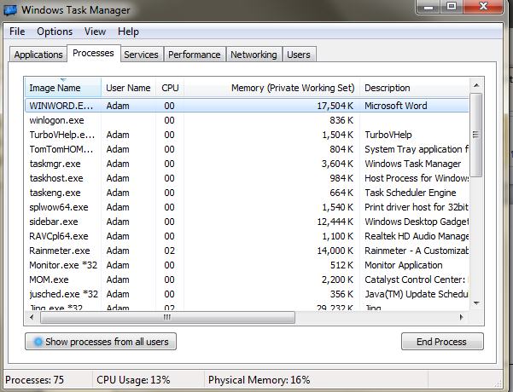

Snip for Task Manager with Safe Mode Start

What processes are missing in Safe Mode?
Cant figure out how to get into safe mode with this version of windows. Sorry!

